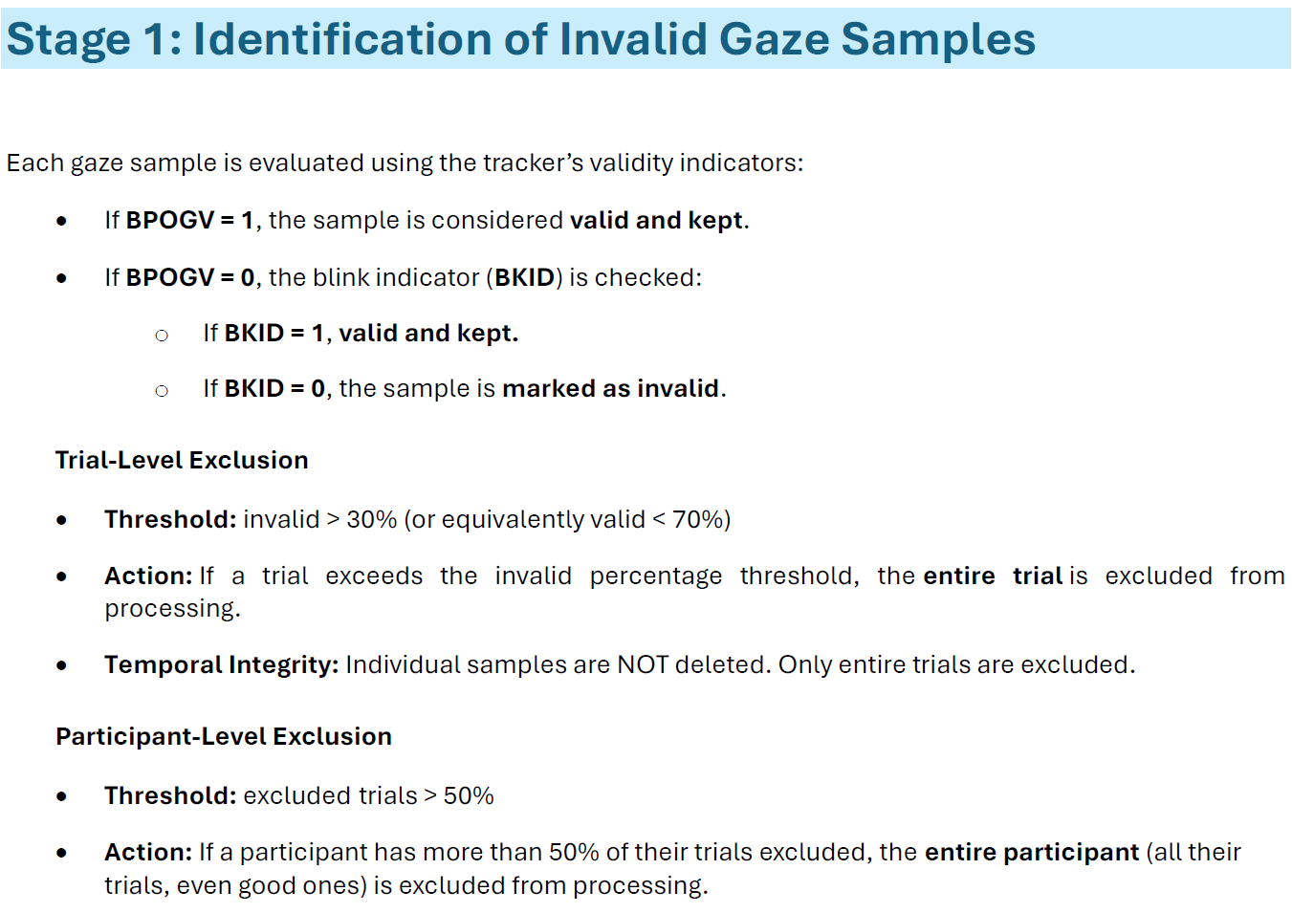
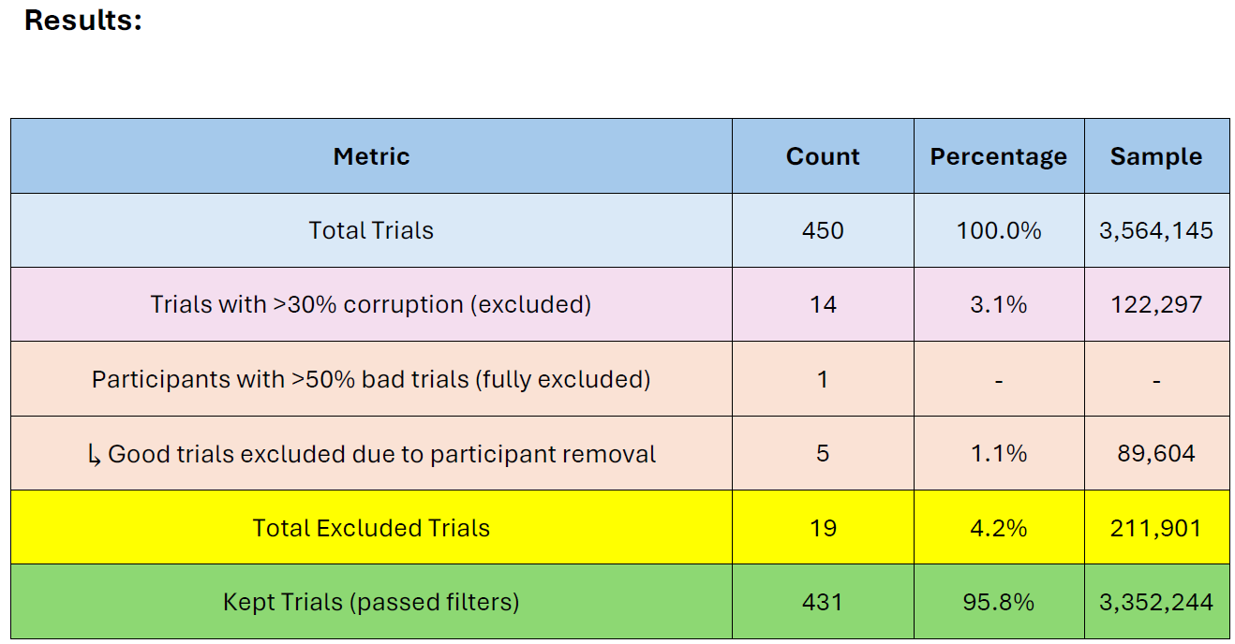
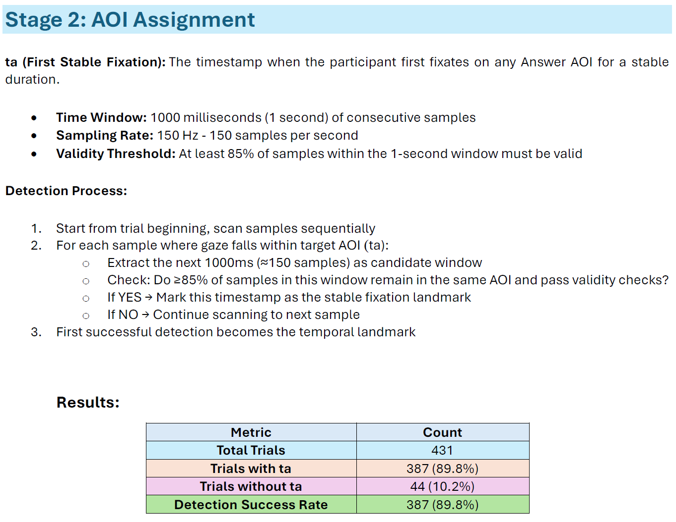
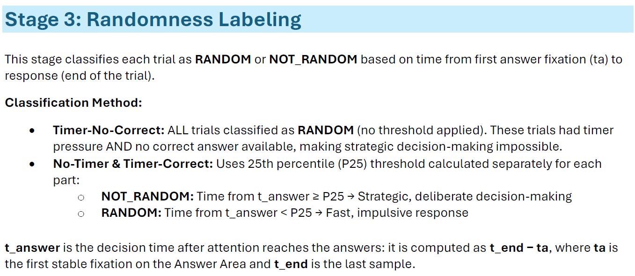
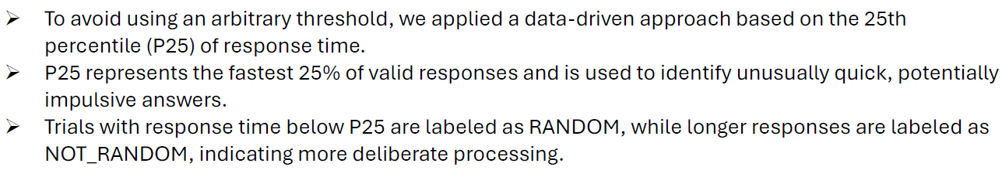
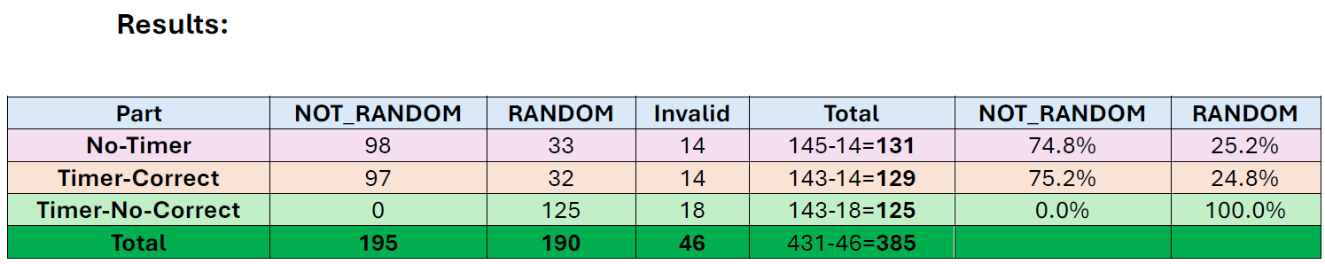
Part | Label | Total | Correct | Incorrect | Correct% | Incorrect%
No-Timer | RANDOM | 33 | 24 | 9 | 72.7% | 27.3%
 | NOT_RANDOM | 98 | 69 | 29 | 70.4% | 29.6%
 | TOTAL | 131 | 93 | 38 | 71.0% | 29.0%
Timer-Correct | RANDOM | 32 | 12 | 9 | 71.9% | 28.1%
 | NOT_RANDOM | 97 | 55 | 42 | 56.7% | 43.3%
 | TOTAL | 129 | 78 | 51 | 60.5% | 39.5%
Timer-No-Correct | RANDOM | 125 | 0 | 125 | 0% | 100%
